FREE the PEACE
Memorial Weekend Celebration
Sunday, May 30th, noon to dusk
Malcolm X/Meridian Hill
Park
Prop1.org WASHINGTONPEACECENTER.ORG
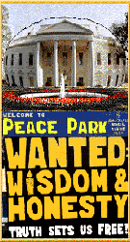   bvfp.org
FAMJAM dawndc.net Black Voices For Peace
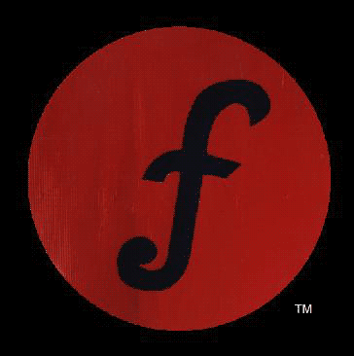
 COMMUNITY COALITION FOR JUSTICE & PEACE

Join the Malcolm X Drummers and Dancers along with the groups above to celebrate and share your visions for Peace.

Hear many musical groups including the ones listed below. There will be an open mike for others who are interested: STEM, REVELMOON, ST.JUDE, DCFUNKSQUAD and
FRANKO & JULIAN from FAMJAM.

Families are encouraged to attend. There will be activities for children.

Contact Free the Peace @ 202 641-4142 or dcmayday@aol.com for more information, to help organize, and be recognized as a sponsor.

