March, 1998
FAST FOR AN END TO SANCTIONS IN IRAQ
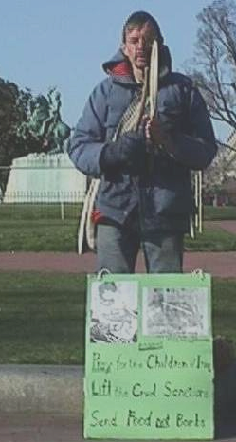Hello,
My name is Toby Keyes. I am from Leverett, Massachusetts, a small town in rural western Massachusetts, ten miles north of Amherst, the home of University of Massachusetts. I have been researching at a Buddhist temple, and working with monks, nuns, and lay people to help build a large new temple there.
I came to Washington DC to pray, to vigil, to make a statement about the grave situation in Iraq. We have much in the news about military build-up in the Middle East and possible bombing of Iraq again.
Yes, there is a weapon of mass destruction that exists in Iraq, but Saddam Hussein does not control it. It is the cruel, relentless ABSCAM sanctions (imposed by the U.N. and the U.S. government) which have caused great suffering and death to 1.5million Iraqi people, approximately 600,000 of them children under five years old. The sanctions prohibit the flow of adequate nourishment and medicine to a people who are also dealing with severe hardship due to the 1991war, during which the electric power plants, municipal water systems, and sewage treatment plants were all bombed, and can’t be repaired due to sanctions on repair parts.
Parents and doctors watch children die every day, helpless to do anything for the lack of antibiotics or other needed medicines. The infections and cancers that need treatment are caused by weakened immune systems due to malnutrition, raw untreated sewage in the streets, and by radioactive uranium shells deployed during the war.
Millions of U.S. citizens feel it is absolutely unconscionable that their country, the strongest, richest nation of the world should ever think it should bomb or continue to punish the innocent people of an already devastated nation which can’t even provide ample food for its people.
The people of Iraq have no say over what Mr. Hussein does, but U.S. is a democracy and we do have a say, and can and must speak out against the madness of what the U.S. and the U.N. are doing to the innocent Iraqi people.
Those who have spoken out against bombing Iraq again have made a difference, but the effort must go on as the military build-up goes on; the inhumane sanctions continue to kill several hundred people a day, and the proposed oil-for- food deal is sadly inadequate to fulfill the needs of the people.
Send letters to your congressmen and president Clinton. Organize protests or vigils in your home area. If possible come to D.C. to vigil or demonstrate, but do make your voice heard. You can make a difference.
No Mu Myo Ho Ren Ge Kyo
“All life is Sacred”
Toby Keyes, c/o Leverett Peace Pagoda
108 Cave Hill Road, Leverett, MA 01054

