FREE the PEACE
Sunday, July 11th , 2004
Noon til Dusk
Malcolm X /Meridian Hill Park
24/7 on point against the war machine.

Prop1.org WASHINGTONPEACECENTER.ORG
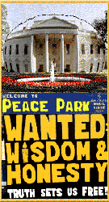   bvfp.org
FAMJAM dawndc.net Black Voices For Peace
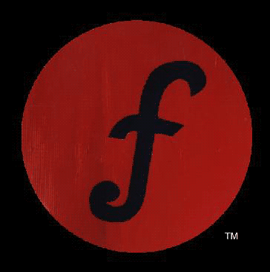 dc guerilla poet insurgency PHOENIX PROJECT
 COMMUNITY COALITION FOR JUSTICE & PEACE

Join the Malcolm X Drummers and Dancers along with the following musical & performance artists, FAITH & JUDE, ELEANOR JOHNSON, ASHAWARRIOR, STEM, STJUDE, BOMANI, PETER MULDOON, FRANKO & JULIAN from FAMJAM and others to celebrate and share your visions to FREE the PEACE and Cage the War Rage!

Meet others in the peace movement and find out how you can get involved.

Families are encouraged to attend. There will be activities for children.

Contact Free the Peace @ 202 641-4142 or dcmayday@aol.com for more information, to help organize, and be recognized as a sponsor.

MORE FREE THE PEACE on 8/11/04 @ Farragut Square & 9/12/04 @ Lafayette Park.

